SelectFileActivity.java: onOptionsItemSelected:



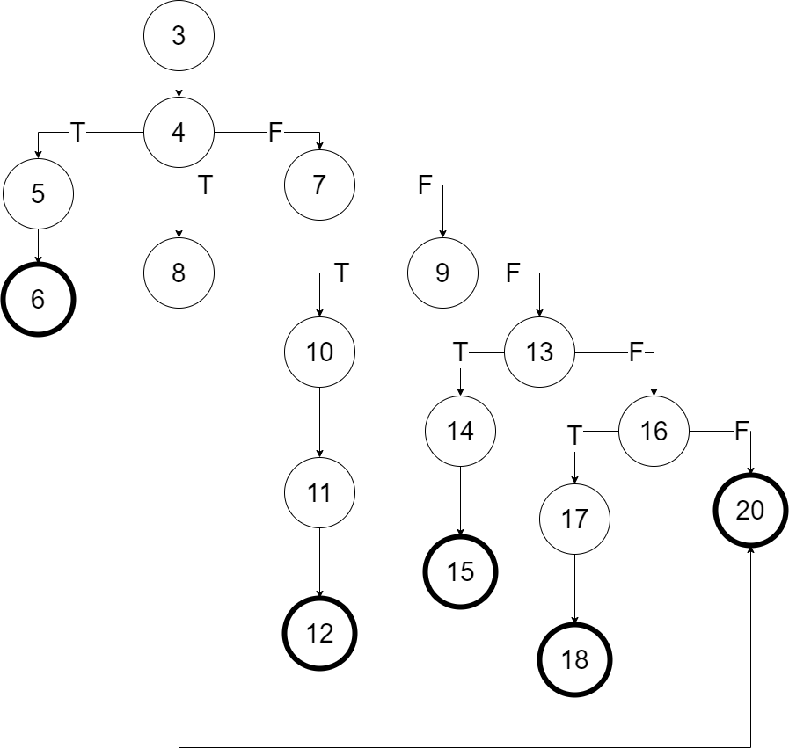

SelectFileActivity.java: onItemClick



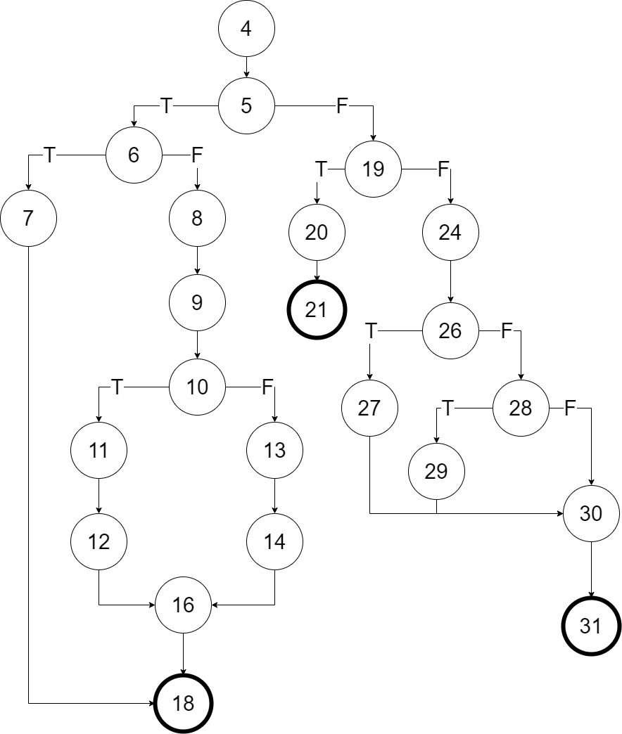

Editor.java: undo



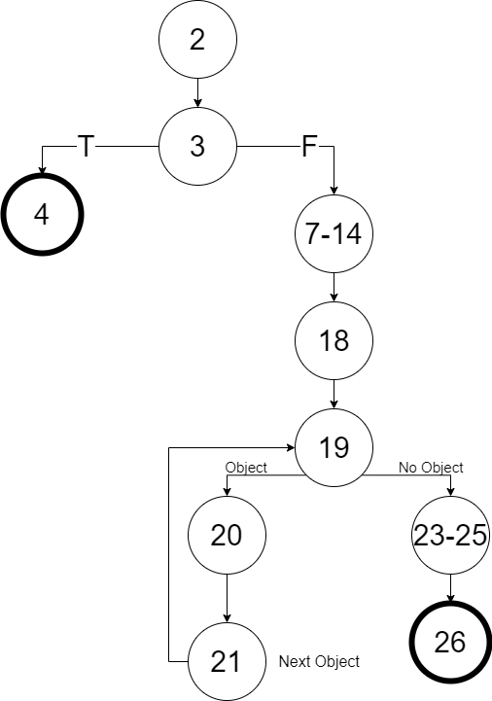

Editor.java: replaceTextKeepCursor



